**MODULAR JUMBO TOILET ROLL DISPENSER**

**Part Code 4TJS-WB**

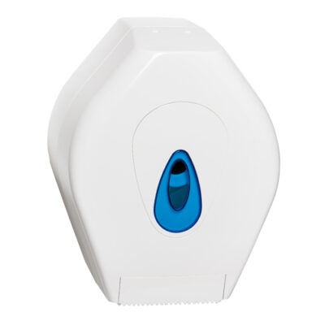

The Modular small jumbo is ideal for small washroom cubicles where space is restricted the unit is strong enough to take on constant day to day use.

The small jumbo is designed to take a 200mm Jumbo roll also features a large front window to check stock levels and a key lockable function for extra security.

**Key Features**

Manufactured in the UK

ABS cover, window & backplate

Reversible spigot fits different roll-core diameters

Perforated and non-perforated paper

Easy restocking

**Suitability / Capacity**

Perforated or non-perforated jumbo rolls

Max width of 110mm and a core size between 45mm and 65mm

200mm jumbo roll

**DIMENSIONS AND WEIGHT**

Height: 275mm, Width: 220mm, Depth: 145mm, Weight: 0.65kg