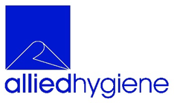 | Sanisafe 3 refill | Allied Hygiene Systems Ltd  5 Centurion Way  Erith, Kent  DA18 4AF  T: 020 8310 4000  F: 020 8311 5566  admin@alliedhygiene.com  www.alliedhygiene.com
 | Allied code B81200303

DESCRIPTION | Sanisafe 3 a Quat free disinfectant formula. Excellent efficacy and kill rate for both Gram-Positive and Gram-Negative organisms

FEATURES | Class leading efficacy at lower temperatures - 5 - 10 degrees Celsius - and under 'dirty' conditions. Quat and PHMB free. Low corrosion on metal and steel surfaces due to low salt content.  Sanisafe wet disinfectant wipes are effective against gram positive and gram-negative bacteria including E-Coli, Staphylococcus Aureus, Pseudomonas Aeruginosa, Enterococcus, Hirae.  Sanisafe 3 is tested and approved to European norms EN1276, EN13697, EN13727, EN1650, EN14476

USAGE | Ideal for disinfection of large food preparation food surfaces, conveyor belts, food storage areas, shelving and food handling equipment. Also suitable for gym equipment due to the low salt content for removing body fats

APPEARANCE | Blue refill bag label on bag and box
SOLUTION | Sanisafe 3
SHEET SIZE | 200mm x 200mm
PER PACK / ROLL | 1000 sheets
ODOUR | Slight pleasant
COLOUR | Blue cloth clear liquid
MSDS | Sanisafe 3

SUBSTRATE GRADE | Medium weight
SUBSTRATE COLOUR | Blue
COMPOSITION | 100% polypropylene

PER CASE | 4
CASE LAYERS | 5
LAYERS | 4
TOTAL PER PALLET | 20 cases

APPROVED BY | 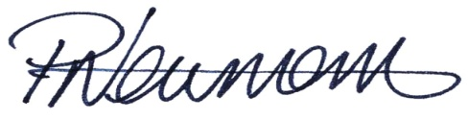  Paul Newman Quality Manager | DATE
 |  | 07/11/2022

